Introduction
In this project, we aim to develop an algorithm using machine learning methods that can diagnose diseases from genomic data. Based on the available data and its hidden characteristics, machine learning algorithms have been applied to the data in two phases:

1. Identifying cases of patients with the NAFLD class and healthy individuals with the Normal class.
2. Identifying the disease severity in individuals using the Advanced NAFLD and Non-advanced NAFLD classes.

To this end, data related to each of these phases has been prepared, and two separate dataset files have been created according to the classes relevant to each phase. These datasets are used as input in the algorithms separately.

Phase One: Normal or NAFLD Classification

In this phase, we aim to apply various classification methods (KNN,MLP,SVM) to data with a simplified class of either Normal or NAFLD, and then compare the results.

Preprocessing
To use the dataset in machine learning algorithms, we first need to preprocess the data to make it computable. Initially, we use the Label Encoder method to encode columns with qualitative values. These columns include Simplified Class, Sex, and Diabet.
To clearly define input and output values, we define two variables, X and Y. The input data is placed in variable X and the output data in variable Y. We consider all dataset columns for X except for the extra columns that won't impact learning. Therefore, we remove the Simplified Class, Run, and Patient ID columns from the dataset. For variable Y, we only consider the Simplified Class column.

Feature Extraction
For feature extraction, we used two methods: Mutual Information Gain and Anova F-test. After examining the outputs, it was determined that Mutual Information Gain provided the best results. Therefore, this method was selected for feature extraction in all approaches.

To examine the impact of the number of features on the results, the program code allows specifying the desired number of features to be extracted at the beginning. Based on this, we interpreted the results from 4 iterations using 5, 10, 15, and 20 extracted features.
Comparison of Extracted Features
The top extracted features from the dataset, based on different patient classifications and disease levels, are as follows:
Advanced or Non Advanced | Normal or NAFLD
ENSG00000100767 | ENSG00000001629
ENSG00000105258 | ENSG00000073614
ENSG00000106624 | ENSG00000106723
ENSG00000110169 | ENSG00000110367
ENSG00000119655 | ENSG00000119487
ENSG00000130429 | ENSG00000127540
ENSG00000139329 | ENSG00000133226
ENSG00000144674 | ENSG00000136738
ENSG00000148943 | ENSG00000139746
ENSG00000164114 | ENSG00000148700
ENSG00000171858 | ENSG00000148700
ENSG00000173917 | ENSG00000163510
ENSG00000177697 | ENSG00000163939
ENSG00000183648 | ENSG00000163946
ENSG00000185088 | ENSG00000164252
ENSG00000186340 | ENSG00000174886
ENSG00000188517 | ENSG00000175854
ENSG00000197956 | ENSG00000185009
ENSG00000198242 | ENSG00000186716

Normalization
To logically compare features, we need to normalize the dataset. We use normalization to create a common scale for the data range in the dataset, which is essential for performing machine learning operations.
Test and Train Set Determination
To create an unseen data set and correctly evaluate the performance of machine learning algorithms, we need to randomly divide the existing data into two sets. One set is used in the training phase, where the algorithm learns the patterns in the data, and the other set is used for testing, where the method is evaluated based on the correct identification of the test set data.
Hyperparameters
Various parameters used in machine learning methods serve as regulators in the algorithm's performance and results. Identifying the best and most suitable parameters for each algorithm requires recognizing hyperparameters and tuning. By testing different values and calculating the algorithm's output, we determine which parameter is appropriate for the chosen machine learning method. For example, in the K-Nearest Neighbor (KNN) method, we identify the best value for parameter K, which determines the number of neighbors in a class, using hyperparameter tuning or in MLP approach finding the right number of hidden layers is valuable.

K-Fold Evaluation and Shuffling
For a correct evaluation of machine learning methods, we use K-fold cross-validation. The existing data is randomly divided into K equal parts and evaluated, with the overall assessment of the different parts providing the final evaluation result. Additionally, to prevent biased data from being fed into the machine for learning, we shuffle the data, ensuring randomness. For evaluation the result we conduct 10-fold cross validation.

KNN Method
Using the parameters obtained from the tuning and hyperparameter process based on the best K value, we apply the KNN algorithm to the Normal or NAFLD data.

KNN Confusion Matrix
Based on the four levels of extracted features, the results are as follows:
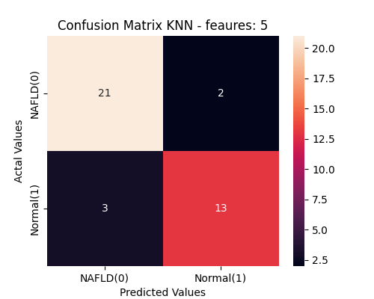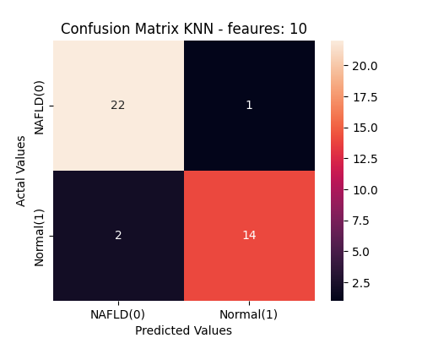
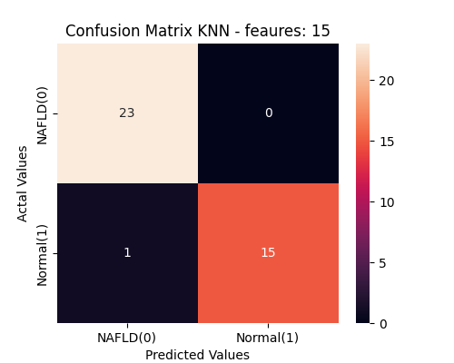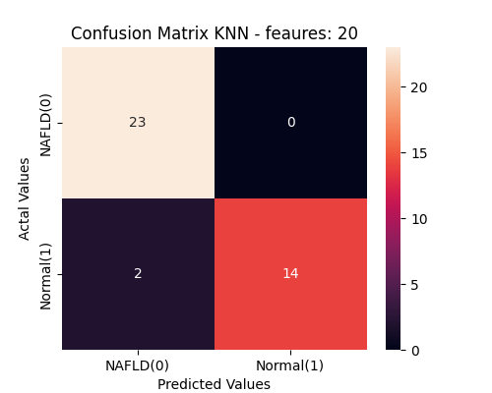
Fig 1- comparison of confusion matrix for various number of extracted features
Accuracy Line Graph
Based on 100 repetitions and different levels of extracted features ranging from 5 to 20, the graphs are as follows:
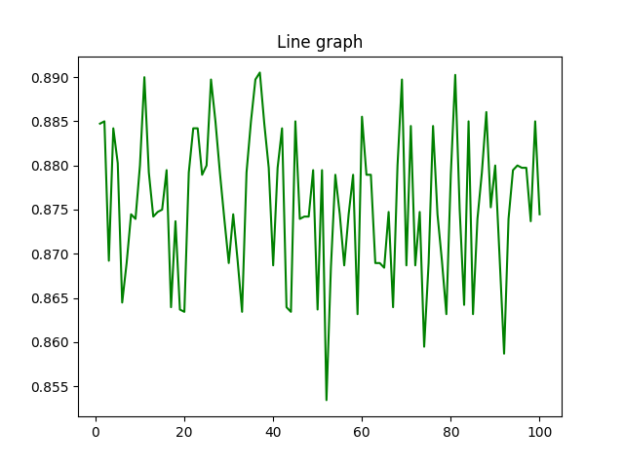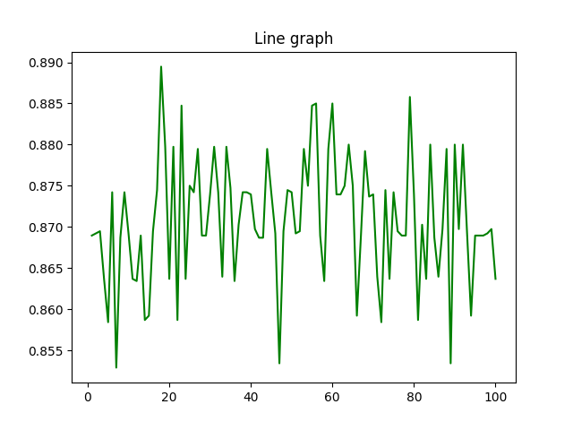
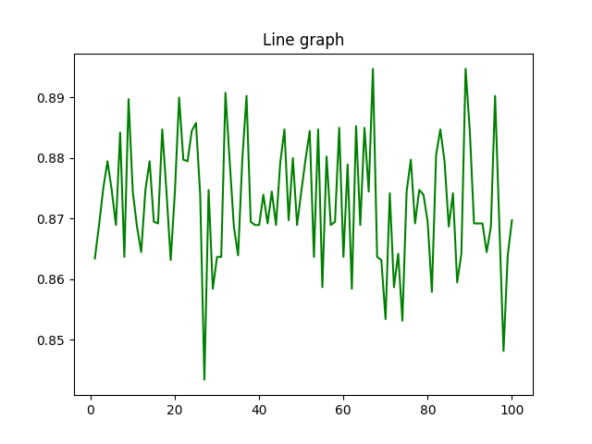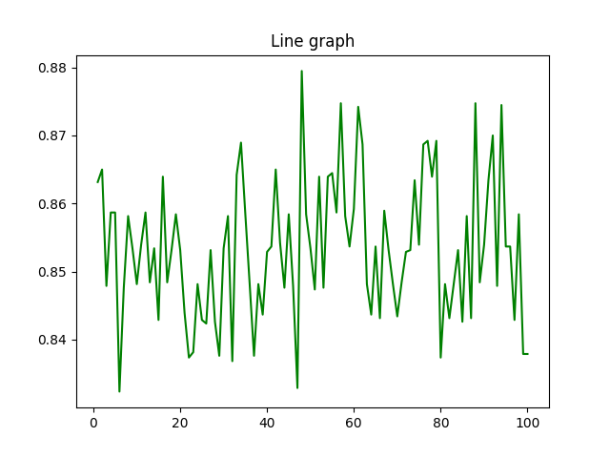
Fig 2 – KNN Accuracy result based on different extracted features and 100 repeated tests
MLP
After applying the Multi-Layer Perceptron algorithm, the results obtained are as follows:
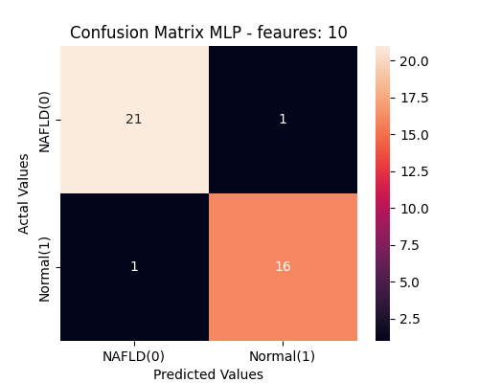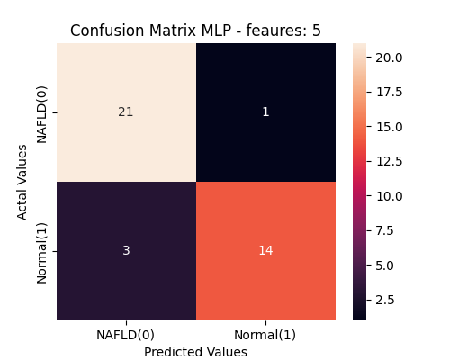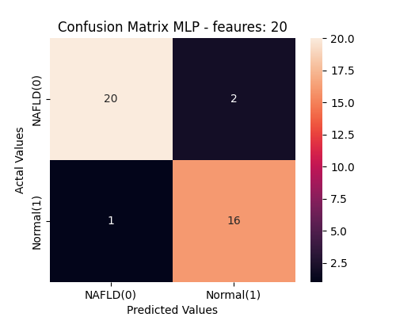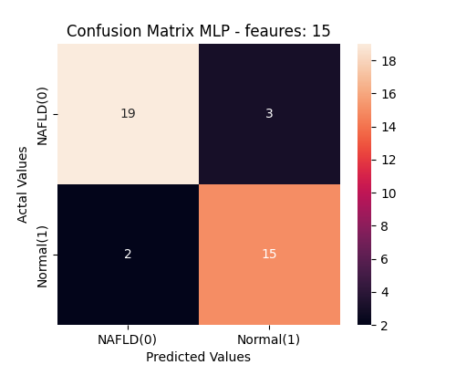
Fig 3- comparison of MLP confusion matrix for various number of extracted features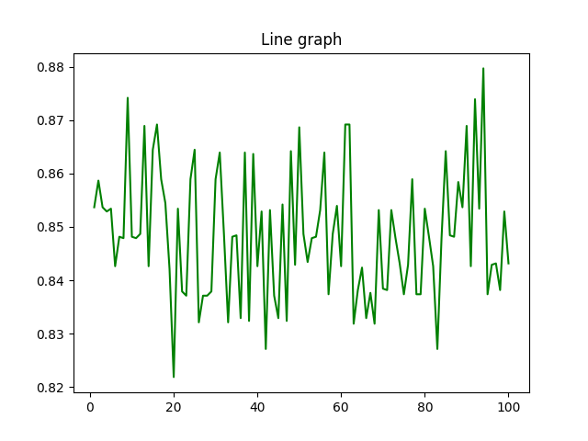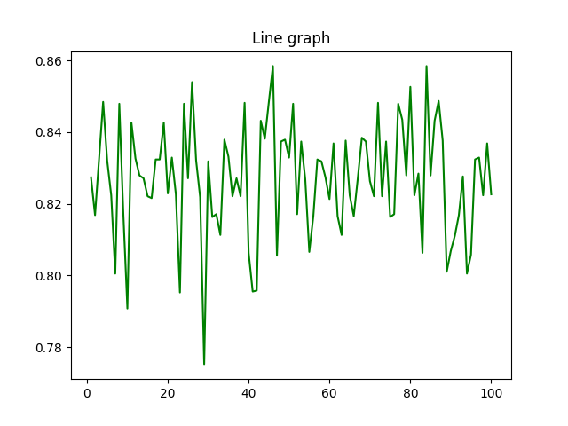
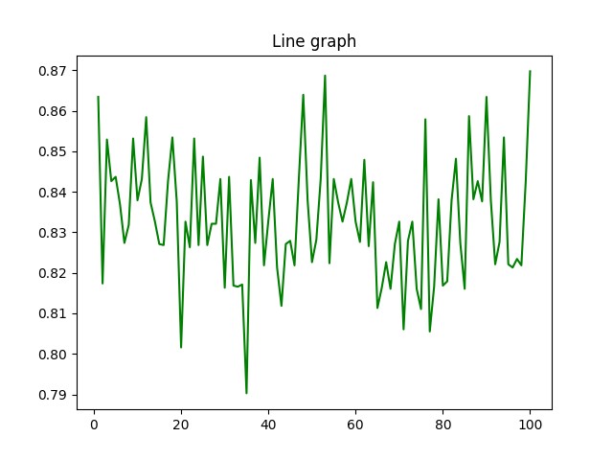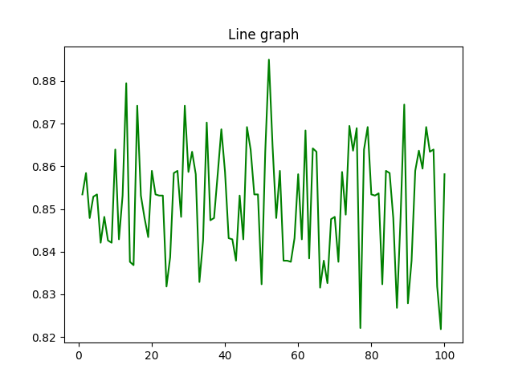
Fig 4 – MLP Accuracy result based on different extracted features and 100 repeated tests
SVM Method
By executing the Support Vector Machine (SVM) algorithm on the NAFLD or Normal dataset, the following results were obtained:
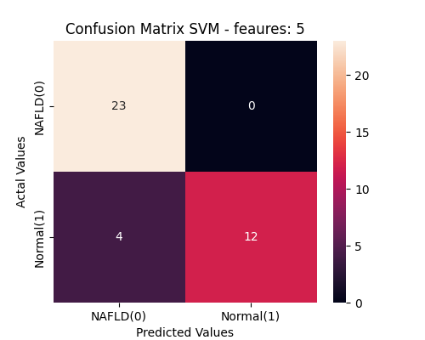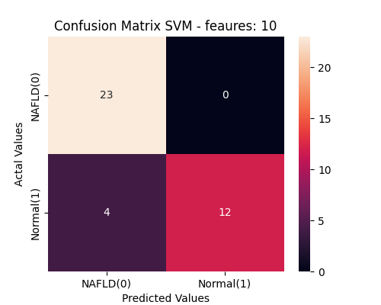
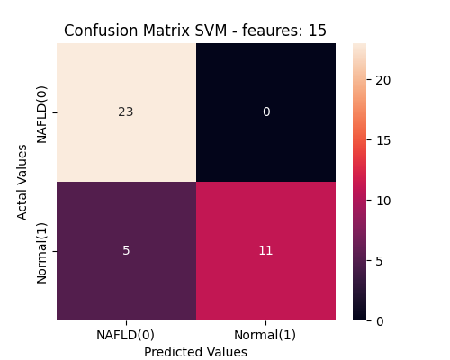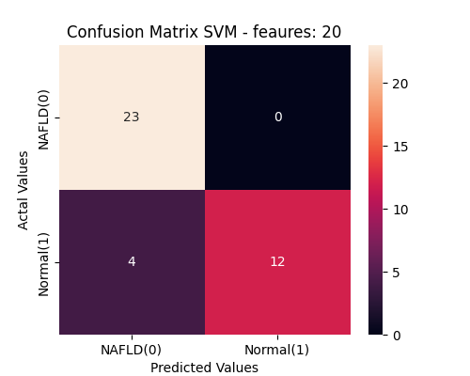
Fig 5- comparison of SVM confusion matrix for various number of extracted features
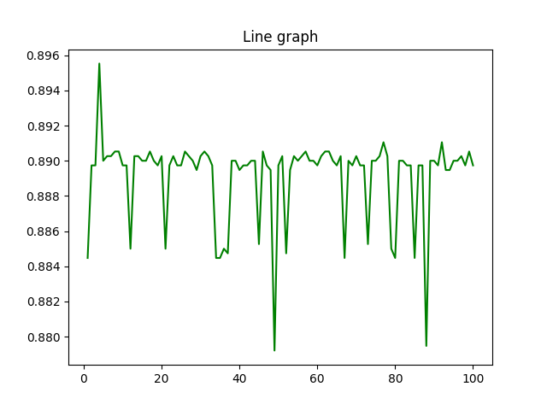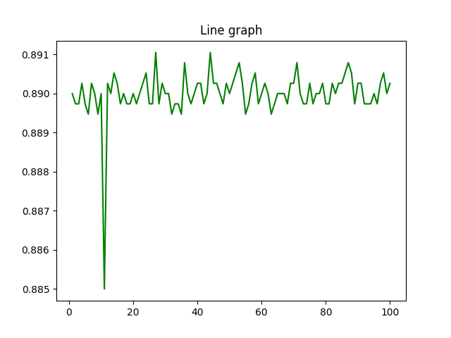
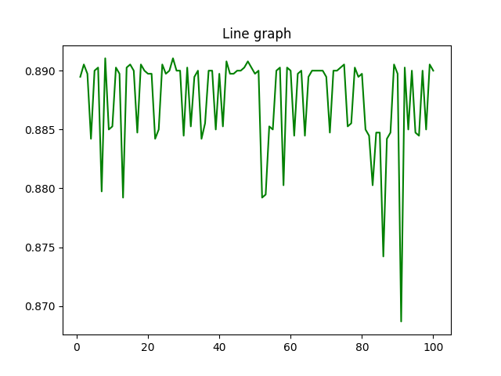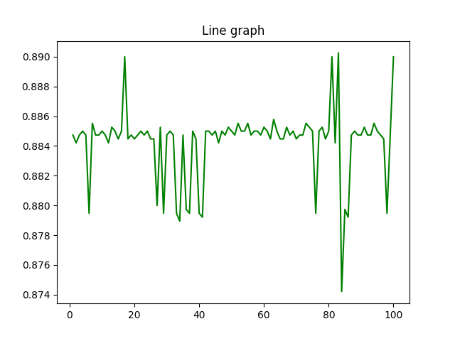
Fig 6 – SVM Accuracy result based on different extracted features and 100 repeated tests

Phase Two: Advanced or Non-Advanced NAFLD
In the second phase, we focus on data with a simplified class of either Advanced or Non-Advanced NAFLD. We aim to examine patients and predict the disease progression level using metadata and genomic data. As before, we will apply various classification methods and compare the results.
KNN
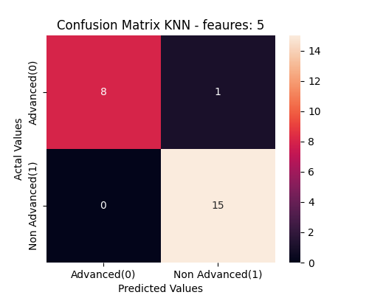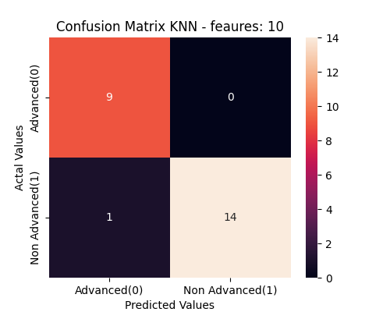
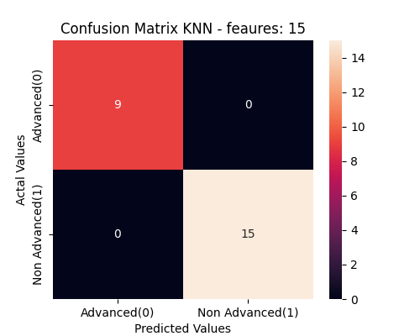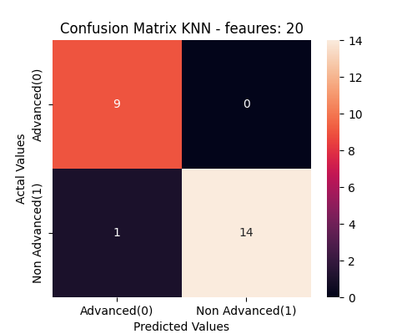
Fig 7- phase 2 comparison of KNN confusion matrix for various number of extracted features
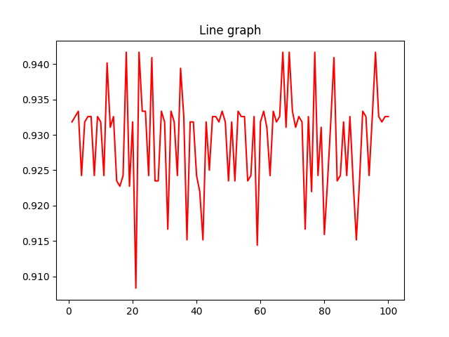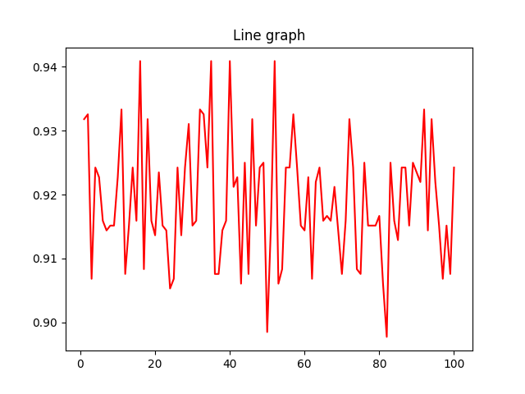
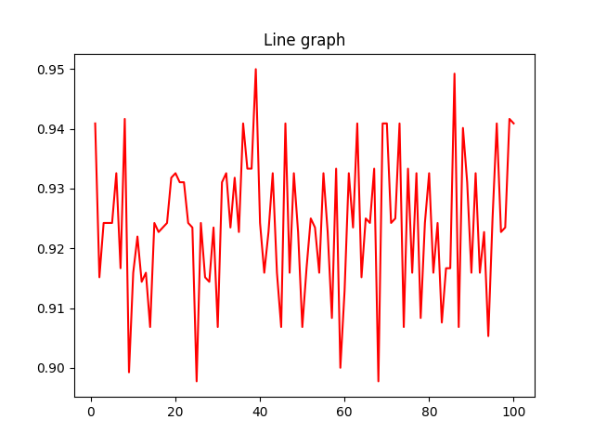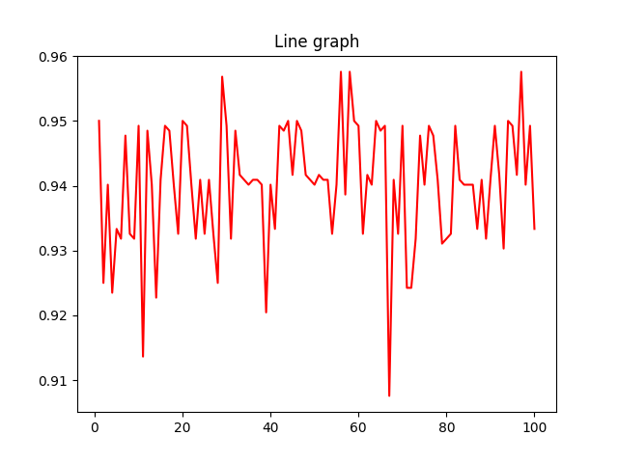
Fig 8 – phase 2 KNN Accuracy result based on different extracted features and 100 repeated tests
MLP
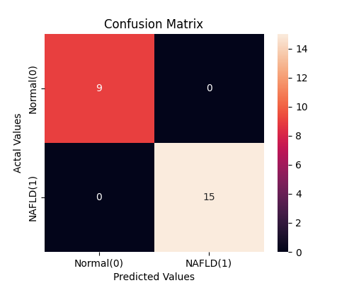

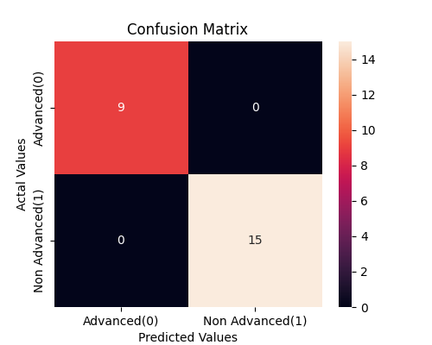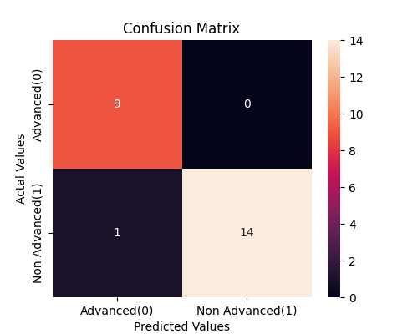
Fig 9- phase 2 comparison of MLP confusion matrix for various number of extracted features
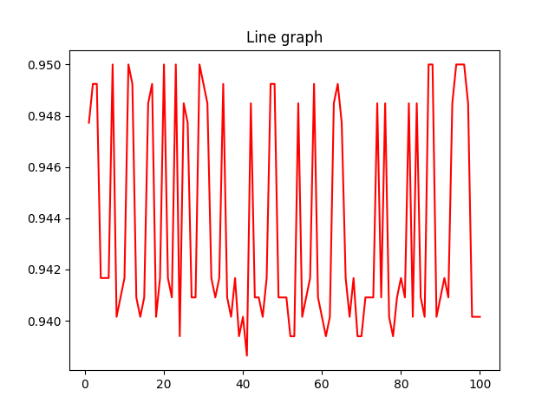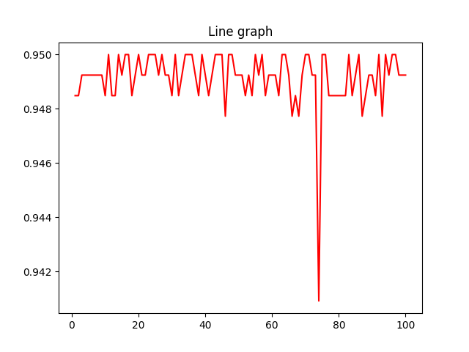
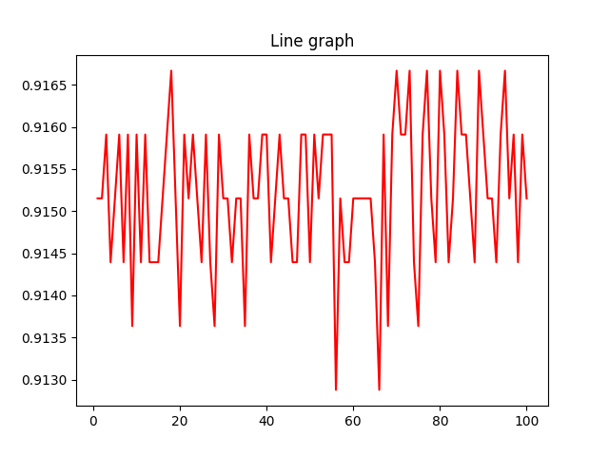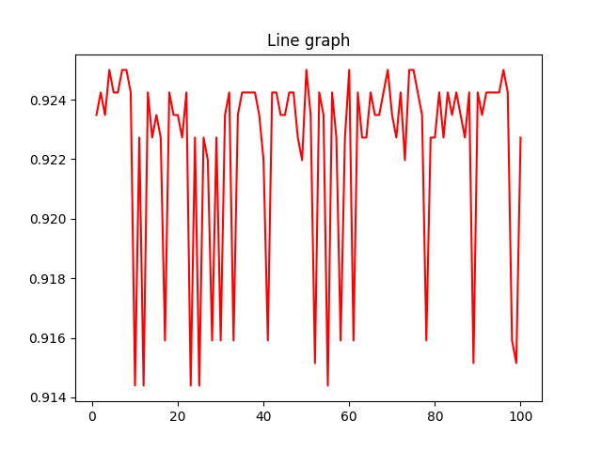
Fig 10 – phase 2 MLP Accuracy result based on different extracted features and 100 repeated tests

SVM
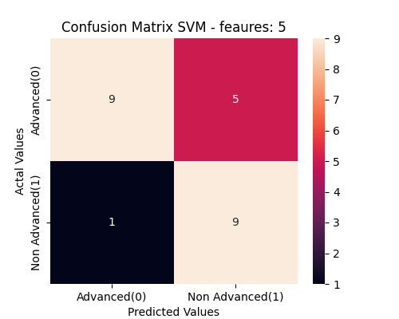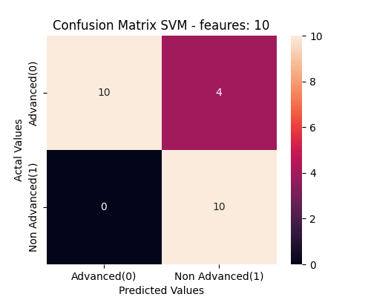
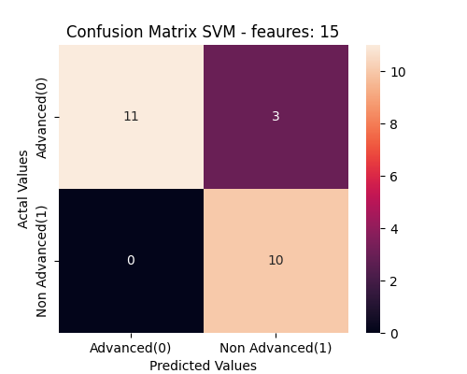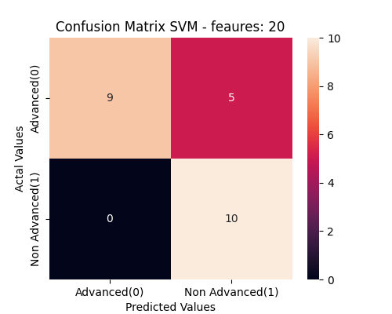
Fig 11- phase 2 comparison of SVM confusion matrix for various number of extracted features

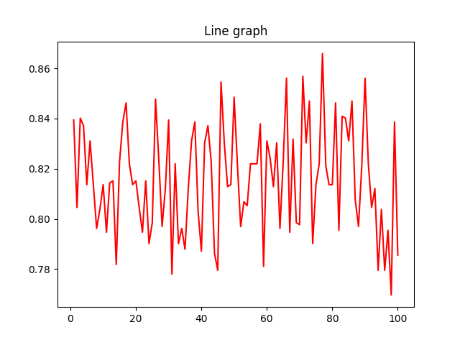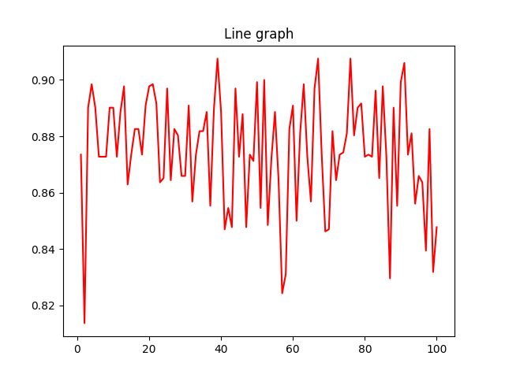
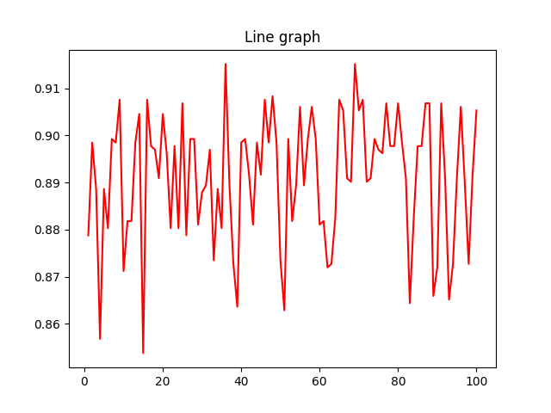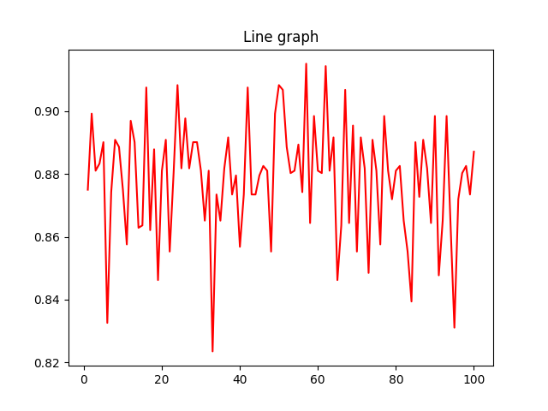
Fig 12 – phase 2 SVM Accuracy result based on different extracted features and 100 repeated tests
Conclusion
The table below compares various machine learning methods applied to different datasets based on the classification of patients as either healthy or having a disease, and further distinguishing between advanced and non-advanced disease levels. The numbers represent the accuracy (ACC) metric, displayed according to the number of extracted features.
100 iteration ACC Mean | TOP 20 features | TOP 15 features | TOP 10 features | TOP 5 features
KNN (Advanced or Non-Advanced) | 0.936909091 | 0.923924242 | 0.918113636 | 0.929212121
MLP (Advanced or Non-Advanced) | 0.922984848 | 0.940462121 | 0.927795455 | 0.931401515
SVM (Advanced or Non-Advanced) | 0.879765152 | 0.887893939 | 0.868659091 | 0.813151515
100 iteration ACC Mean | TOP 20 features | TOP 15 features | TOP 10 features | TOP 5 features
KNN (Normal of NAFLD) | 0.920444737 | 0.931173684 | 0.934168421 | 0.897155263
MLP (Normal of NAFLD) | 0.907465789 | 0.925910526 | 0.947739474 | 0.906555263
SVM (Normal of NAFLD) | 0.894994737 | 0.889523684 | 0.887889474 | 0.874442105

Summary
- KNN: The accuracy improves gradually with an increase in the number of features. It performs slightly better on the Advanced vs. Non-advanced NAFLD dataset.
- MLP: Shows the 2nd highest accuracy among the methods, with noticeable improvement as the number of features increases and performs better when applied on Advanced vs. Non-advanced dataset.
- SVM: Consistently performs well, but with accuracy slightly below MLP and KNN, also it performs better on Normal vs. NAFLD dataset.
This comparison helps in identifying the most effective machine learning method for the given classification tasks based on accuracy and the number of features used.

